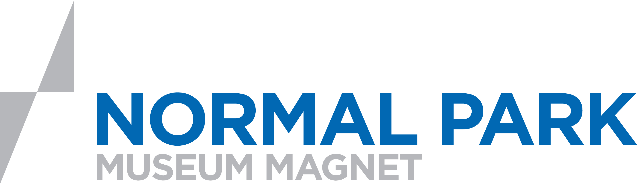

Related Arts Planning Form- Q3
*The core teachers & related arts teachers meet before each quarter to plan, so everyone is on the same page as to what pieces each related arts is contributing to the exhibit. This is the plan from 1st grade’s meeting.

ART  -State flags  -American symbols (clay)  -State plates (ceramic)  -American Portraits (pastels) | MUSIC (Performance on Exhibit Night)  -Tennessee Waltz  -Star Spangled Banner  -Fifty Nifty  -Follow Mw Through Tennessee
LIBRARY  Famous Tennesean PowerPoint (Each class studies 2 famous Tenneseans- listed in standards & creates a Powerpoint slide. The slides will be presented to all the 1st graders. | SPANISH  Folk tale from Puerto Rico (students illustrate)

